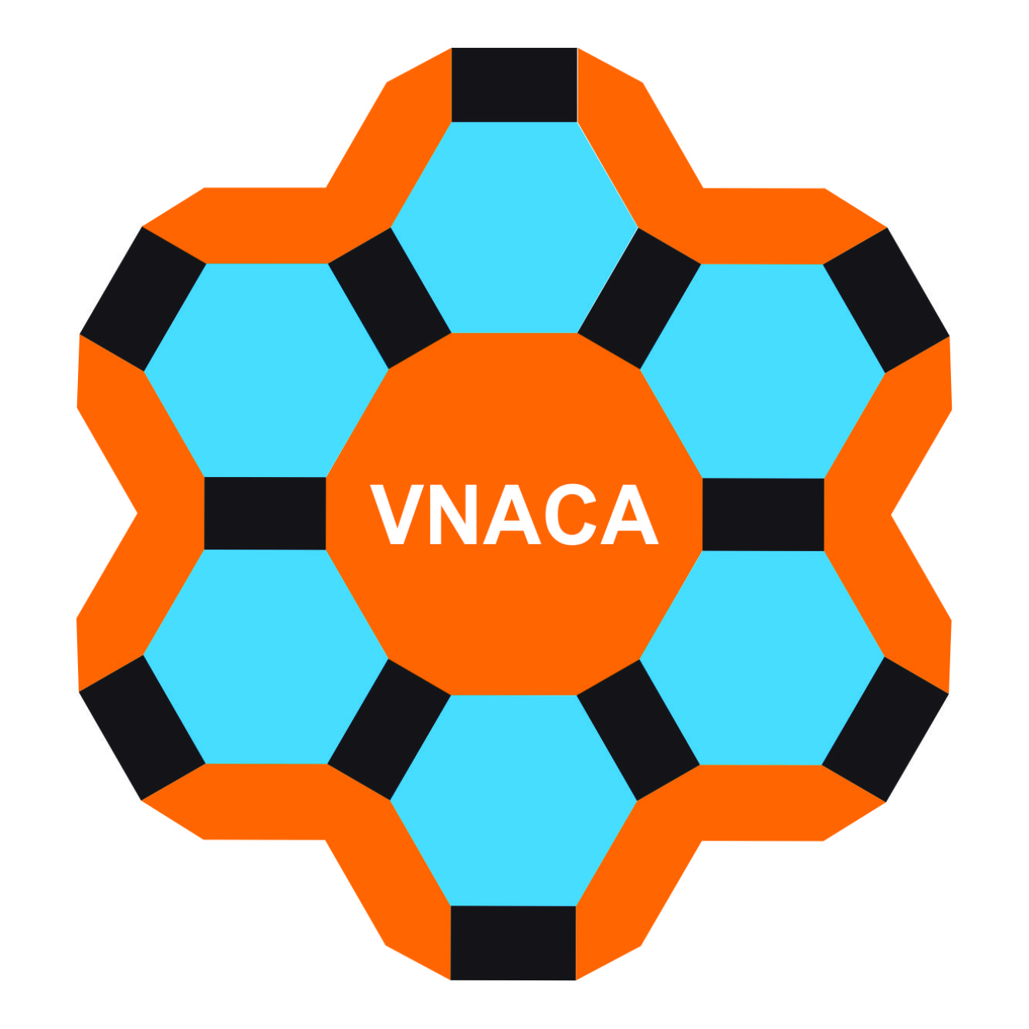 | Vietnam Journal of Catalysis and Adsorption  Tạp chí xúc tác và hấp phụ Việt Nam  http://chemeng.hust.edu.vn/jca/

Title font Segoe UI Light 13 point, bold

Author names font Segoe UI Light 11 point, Nguyen Van A¹, Trinh Van B², Pham Thu Tra^{1,*}

¹ Affiliation including Department, University or Organization, City, State and Country for all authors
² School of Chemical Engineering, Hanoi University of Science and Technology, Hanoi, VIETNAM
*Email: tra.phamthu@hust.edu.vn

ARTICLE INFO |  | ABSTRACT
Received:  Accepted: |  | Abstracts should not exceed more than 150 words and should not contain literature references. An abstract may not be necessary for short communications. The symbols, abbreviations, units, and nomenclature used in the text should be in conformity with the recommendations of IUPAC. It should clearly state the purpose of the work, methods used, key findings and major conclusion drawn from the work (Font Segoe UI Light 10 point).
Keywords:
3 to 5 keywords; Font Segoe UI Light; 10 point

